CMSC 345

Software Design and Development

Fall 2013

**Code To Joy - Shortest Distance**

Matthew Barteau

Benjamin Walsh

Sean Hutchinson

Amanda Hartman

Xuanzhu Zhu

John Pham

**Customer:**

Vishnugopal Rajamanickam

**System Requirements Specification**

**Table of Contents**

Page

1. Introduction 3

* Purpose of This Document
* References
* Purpose of the Product
* Product Scope

2. Functional Requirements 4-12

3. Non-Functional Requirements 12

3.1 Customer Constraints

3.2 External Interfaces

3.3 Other

4. Deliverables 12-13

5. Open Issues 13

6. Appendix A 14

**Document Versioning Control**

|  |  |  |
| --- | --- | --- |
| **Version Number** | **Date** | **Changes from Previous Version** |
| 1.0 | 10/8/2013 | N/A |
| 1.01 | 10/17/2013 | Replaced all instances of “will” with “shall”  Added UML diagrams  Removed a few Non-functional requirements  Removed customer constraints  Removed “system” as a primary actor from a few cases |
| 1.02 | 10/29/2013 | Added location files in UML diagram |

1. **Introduction**

1.1 Purpose of This Document

The purpose of the Software Requirement Specification is to outline the requirements for Code To Joy's "Shortest Distance"(SD) application. SD shall be coded with Java and include the Google Earth API. It shall be an application usable on windows computers.

1.2 References

1. System Requirements Specification Template

2. <https://developers.google.com/earth/> for research about the Google Earth API

3. Requirements lecture from 9/5/13

4. Use case diagram originally from Basic Use Case Template, by Alistair Cockburn, <http://members.aol.com/acockburn/papers/uctempla.htm>, accessed 1/17/08.

1.3 Purpose of the Product

The purpose of SD is to find the shortest total distance between multiple locations given a start and stop location. This shall make it so that if a user wants to travel to multiple locations in a day, they shall be able to travel the shortest distance to get to all locations. SD shall show the shortest distance using Google Earth API so that the user can see the that it is actually the shortest distance. It can also be used to plan out future trips with a email reminder when the date is close. This shall be useful if a user knows where they want to go, but do not want to go right away.

1.4 Product Scope

Shortest Distance currently consists of 11 use cases. These include letting the user add locations to their trip, choosing a start and stop location, getting the shortest distance between multiple locations, administrators adding locations, administrators removing locations, administrators editing locations, and displaying the shortest distance using Google Earth’s API. It shall be a standalone desktop application using Google Earth’s API.

2. **Functional Requirements**

2.1 **Use Case 1**

|  |  |  |
| --- | --- | --- |
| **Number** | 1 |  |
| **Name** | Select Locations |  |
| **Summary** | The user shall select multiple locations |  |
| **Priority** | 5 |  |
| **Preconditions** | There must be locations in the system to choose from |  |
| **Postconditions** | The user shall have locations added to their trip |  |
| **Primary Actor** | User |  |
| **Secondary Actors** | None |  |
| **Trigger** | The user enters the system's "select location" part |  |
| **Main Scenario** | **Step** | **Action** |
|  | 1 | The user shall select a location they wish to visit |
|  | 2 | The system adds location to the user's trip list |
| **Extensions** | **Step** | **Branching Action** |
|  | 1a | The user tries to add a location that is not in the system |
| **Open Issues** | None |  |

2.2 **Use Case 2**

|  |  |  |
| --- | --- | --- |
| **Number** | 2 |  |
| **Name** | Select Start Location |  |
| **Summary** | The user shall select the starting location |  |
| **Priority** | 5 |  |
| **Preconditions** | There must be a location in the user's trip |  |
| **Postconditions** | The user shall have a start location to their trip |  |
| **Primary Actor** | User |  |
| **Secondary Actors** | None |  |
| **Trigger** | The user finishes selecting all locations |  |
| **Main Scenario** | **Step** | **Action** |
|  | 1 | The user shall select a location they shall start at |
|  | 2 | The system shall make that location the user's starting location on his trip |
| **Extensions** | **Step** | **Branching Action** |
|  |  | None |
| **Open Issues** | None |  |

2.3 **Use Case 3**

|  |  |  |
| --- | --- | --- |
| **Number** | 3 |  |
| **Name** | Select End Location |  |
| **Summary** | The user shall select the ending location |  |
| **Priority** | 5 |  |
| **Preconditions** | There must be a location in the user's trip |  |
| **Postconditions** | The user shall have an end location to their trip |  |
| **Primary Actor** | User |  |
| **Secondary Actors** | None |  |
| **Trigger** | The user added a start location to their trip |  |
| **Main Scenario** | **Step** | **Action** |
|  | 1 | The user shall select a location they shall end at |
|  | 2 | The system shall make that location the user's ending location on his trip |
| **Extensions** | **Step** | **Branching Action** |
|  |  | None |
| **Open Issues** | None |  |

2.4 **Use Case 4**

|  |  |  |
| --- | --- | --- |
| **Number** | 4 |  |
| **Name** | Shortest Distance |  |
| **Summary** | The system shall find the shortest total distance between all locations given a start and stop location |  |
| **Priority** | 5 |  |
| **Preconditions** | There must be a location in the user's trip.  There must be a start in the user's trip.  There must be a stop in the user's trip. |  |
| **Postconditions** | The shortest distance between the locations shall be calculated by the System |  |
| **Primary Actor** | System |  |
| **Secondary Actors** | User |  |
| **Trigger** | The user added an ending location to their trip |  |
| **Main Scenario** | **Step** | **Action** |
|  | 1 | The system shall use an algorithm to determine shortest total distance |
|  | 2 | The system shall use the shortest distance to make a priority of which place to visit |
| **Extensions** | **Step** | **Branching Action** |
|  |  | None |
| **Open Issues** | None |  |

2.5 **Use Case 5**

|  |  |  |
| --- | --- | --- |
| **Number** | 5 |  |
| **Name** | Schedule for later |  |
| **Summary** | The user can schedule his trip for a later date. |  |
| **Priority** | 3 |  |
| **Preconditions** | There must be a valid date in the future that they want to travel. |  |
| **Postconditions** | The user shall have a date in the future that they shall be able to make a trip for. |  |
| **Primary Actor** | User |  |
| **Secondary Actors** | None |  |
| **Trigger** | The user uses the system's option to use a different date |  |
| **Main Scenario** | **Step** | **Action** |
|  | 1 | The user shall select they wish to use a date in the future |
|  | 2 | The user shall select the date they wish to use |
| **Extensions** | **Step** | **Branching Action** |
|  | 1a | The user tries to add a date that is not valid |
| **Open Issues** | None |  |

2.6 **Use Case 6**

|  |  |  |
| --- | --- | --- |
| **Number** | 6 |  |
| **Name** | Print trip |  |
| **Summary** | The trip with the shortest distance shall be printed using Google Earth's API |  |
| **Priority** | 5 |  |
| **Preconditions** | The shortest distance must have been calculated.  Each location must have been giving a priority based on shortest distance. |  |
| **Postconditions** | The shortest distance route shall be shown using the Google Earth's API |  |
| **Primary Actor** | Google Earth API |  |
| **Secondary Actors** | user |  |
| **Trigger** | The system gives a priority to each location |  |
| **Main Scenario** | **Step** | **Action** |
|  | 1 | The system shall use Google Earth API to give it all the locations |
|  | 2 | Google Earth API should print out the route in the order of locations given |
| **Extensions** | **Step** | **Branching Action** |
|  |  | None |
| **Open Issues** | None |  |

2.7 **Use Case 7**

|  |  |  |
| --- | --- | --- |
| **Number** | 7 |  |
| **Name** | View Help File |  |
| **Summary** | The User shall be able to view the help file |  |
| **Priority** | 2 |  |
| **Preconditions** | There must be a help file in the system |  |
| **Postconditions** | The user shall have knowledge of how to use the application |  |
| **Primary Actor** | User, System |  |
| **Secondary Actors** | none |  |
| **Trigger** | The user selects to go to the help section of the system |  |
| **Main Scenario** | **Step** | **Action** |
|  | 1 | The user shall select the help option |
|  | 2 | The system shall display a help file |
| **Extensions** | **Step** | **Branching Action** |
|  |  | none |
| **Open Issues** | None |  |

2.8 **Use Case 8**

|  |  |  |
| --- | --- | --- |
| **Number** | 8 |  |
| **Name** | Create Account |  |
| **Summary** | The system shall create user accounts |  |
| **Priority** | 5 |  |
| **Preconditions** | There must not already be a user account with the same name. |  |
| **Postconditions** | The user shall have a unique account name and password |  |
| **Primary Actor** | User |  |
| **Secondary Actors** | other user's who want that user name, File |  |
| **Trigger** | The user goes to the registration part of the application |  |
| **Main Scenario** | **Step** | **Action** |
|  | 1 | The user shall select desired username |
|  | 2 | The user shall select password |
|  | 3 | The user shall repeat password |
|  | 4 | The System shall create a username for that user with given password |
| **Extensions** | **Step** | **Branching Action** |
|  | 1.a | The user selects a username that is already take |
| **Open Issues** | If user selects a username that is taken. |  |

2.9 **Use Case 9**

|  |  |  |
| --- | --- | --- |
| **Number** | 9 |  |
| **Name** | Administrator Add location |  |
| **Summary** | Administrators shall be able to add locations to the system |  |
| **Priority** | 2 |  |
| **Preconditions** | The user must be an Administrator.  The administrator must have a valid location to add. |  |
| **Postconditions** | The system shall have a location added to it |  |
| **Primary Actor** | Administrator, System |  |
| **Secondary Actors** | Users |  |
| **Trigger** | The administrator uses the Admin Add feature of the application |  |
| **Main Scenario** | **Step** | **Action** |
|  | 1 | The administrator shall choose the Admin Add feature |
|  | 2 | The administrator shall add the location of the new site |
|  | 3 | The system shall update with the new site in it's list of locations |
| **Extensions** | **Step** | **Branching Action** |
|  |  | none |
| **Open Issues** | None |  |

2.10 **Use Case 10**

|  |  |  |
| --- | --- | --- |
| **Number** | 10 |  |
| **Name** | Administrator Remove location |  |
| **Summary** | Administrators shall be able to remove locations from the system |  |
| **Priority** | 2 |  |
| **Preconditions** | The user must be an Administrator.  The system must have the location the Administrator wishes to remove. |  |
| **Postconditions** | The system shall have the location removed from it |  |
| **Primary Actor** | Administrator, System |  |
| **Secondary Actors** | Users |  |
| **Trigger** | The administrator uses the Admin Remove feature of the application |  |
| **Main Scenario** | **Step** | **Action** |
|  | 1 | The administrator shall choose the Admin Remove feature |
|  | 2 | The administrator shall remove the location of the new site |
|  | 3 | The system shall update with the site removed from it in it's list of locations |
| **Extensions** | **Step** | **Branching Action** |
|  |  | none |
| **Open Issues** | If the administrator removes a site that is in someone's upcoming trip. |  |

2.11 **Use Case 11**

|  |  |  |
| --- | --- | --- |
| **Number** | 11 |  |
| **Name** | Administrator Edit location |  |
| **Summary** | Administrators shall be able to edit locations on the system. |  |
| **Priority** | 2 |  |
| **Preconditions** | The user must be an Administrator.  They system must have a location in it. |  |
| **Postconditions** | The location in the system shall be edited |  |
| **Primary Actor** | Administrator, System |  |
| **Secondary Actors** | Users |  |
| **Trigger** | The administrator uses the Admin Edit feature of the application |  |
| **Main Scenario** | **Step** | **Action** |
|  | 1 | The administrator shall choose the Admin Edit feature |
|  | 2 | The administrator shall edit the location in the system. |
|  | 3 | The system shall update with the new edited information in it's list of locations |
| **Extensions** | **Step** | **Branching Action** |
|  |  | none |
| **Open Issues** | If the administrator edits a location and it messes up someone's existing trip. |  |

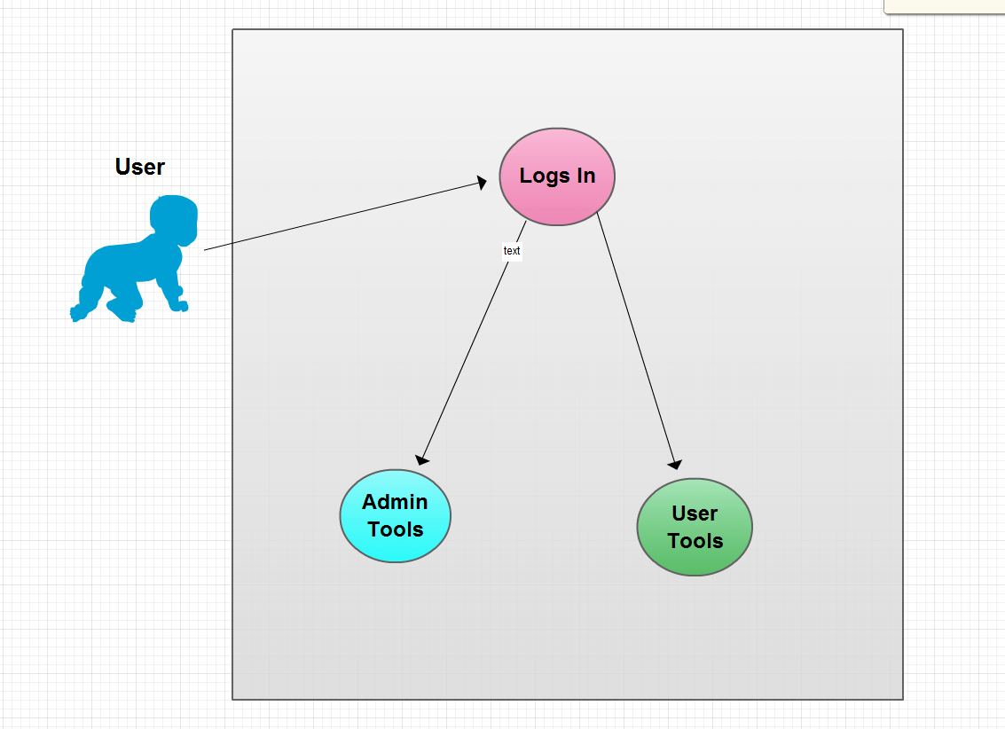

Admin Tools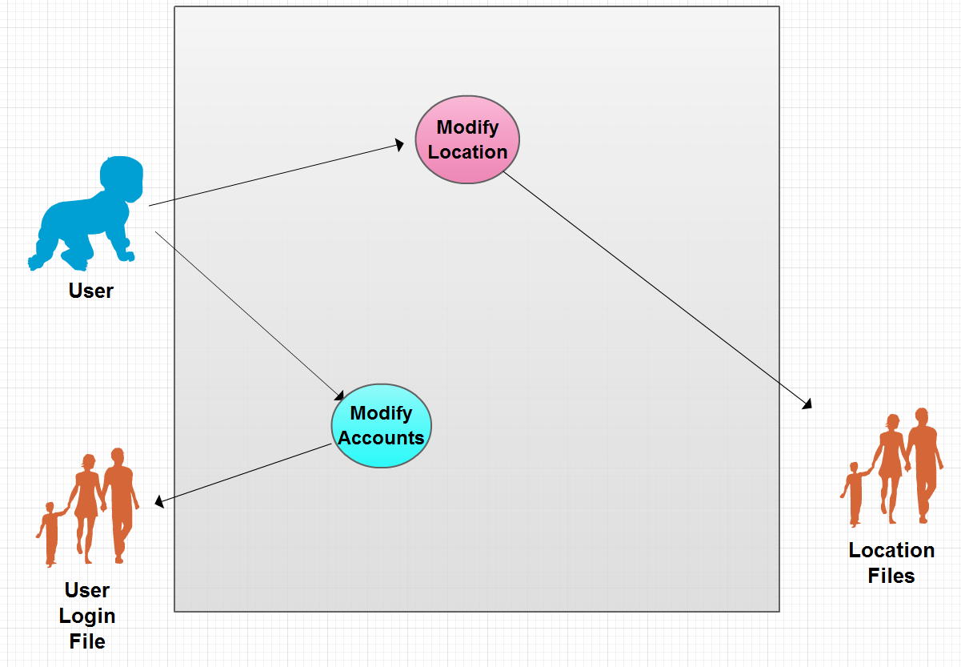

User Tools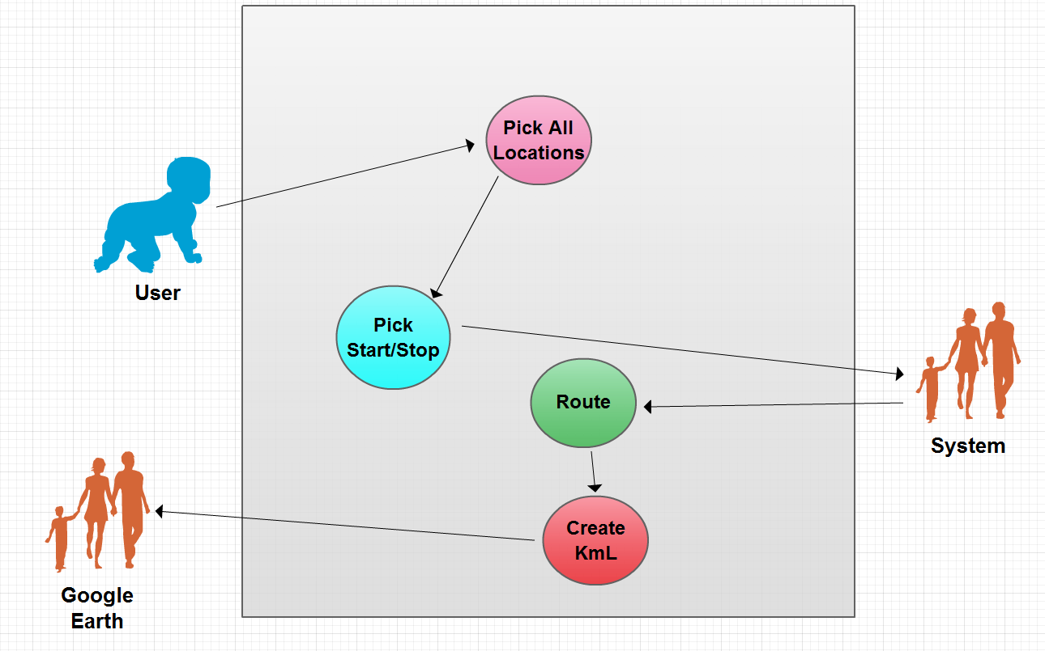



Location Files

3. **Non-Functional Requirements**

|  |  |  |
| --- | --- | --- |
| # | Item | Priority  (1 lowest - 5 highest) |
| NFR0.1 | The information from users shall be secured | 1 |
| NFR0.2 | The coding style shall be consistent | 5 |
| NFR0.3 | The System shall be written in Java | 3 |

3.1 Customer Constraints

N/A

3.2 External Interfaces

There was no requirement from the Customer about external interfaces.

3.3 Other

NFR0.1 The system shall keep the information gathered from the user secured.

NFR0.2 The coding style shall remain consistent throughout all files

4. **Deliverables**

The deliverables shall include the following:

* Systems Requirement Specification
* System Design Document
* User Interface Design Document
* User’s Manual
* Administrator’s Manual
* Copies of all Status Reports

A CD, 3-ring binder, and electronic copy in ZIP file format containing the following:

* System Requirements Specifications
* System Design Document
* User Interface Design Document
* User’s Manual
* Administrator’s Manual
* All source code
* The executable program

5. **Open Issues**

OI.1 If the user name is taken when user tries to create account.  
 Resolution shall be to reprompt them (fix date unknown)

OI.2 If administrator removes a location that is in a user's trip

Resolution is unknown at the moment (fix date unknown)

OI.3 If administrator edits a location that is in the user's trip

Resolution is unknown at the moment (fix date unknown)

Appendix A - Team sign off, Customer acceptance

**Sign off Agreement Between Customer and Contractor**

The customer and the contractors agree to the development of stand alone desktop application which shall find the shortest distance between given locations. It shall have a feature for future trips as per Vishnugopal Rajamanickam. If any future changes are made to the System Requirements Specification (SRS) document or if any additional features are proposed, we shall notify the developers and their customer via e-mail or in person of the conducted changes and proposals.

Amanda Hartman ________________________ _____________

Comments: ______________________________________________

Sean Hutchinson ________________________ _____________

Comments: ______________________________________________

Matthew Barteau ________________________ _____________

Comments: ______________________________________________

Xuanzhu Zhu ________________________ _____________

Comments: ______________________________________________

John Pham _________________________ _____________

Comments: ______________________________________________

Benjamin Walsh _________________________ _____________

Comments: ______________________________________________

Customer:

Vishnugopal Rajamanickam

__________________________ ______________

Comments: ______________________________________________

**Team Review Signoff**

I agree that I have read the above document and reviewed its content. If I do not agree with anything pertaining to the content or format of the document, I shall write it in the comments section below.

**Members of the Team: Signatures: Date:**

Amanda Hartman ________________________ _____________

Comments: ______________________________________________

Sean Hutchinson ________________________ _____________

Comments: ______________________________________________

Matthew Barteau ________________________ _____________

Comments: ______________________________________________

Xuanzhu Zhu ________________________ _____________

Comments: ______________________________________________

John Pham _________________________ _____________

Comments: ______________________________________________

Benjamin Walsh _________________________ _____________

Comments: ______________________________________________